Synamedia MEG setup – **HSN**

HSN2 HD MP4 SDI Out

**Task-** Configuring Synamedia MEG IRDs

**Condition-** Video Decoding HSN2 HD from MP4 - SDI OUT

**Standard-** How to configure a Synamedia MEG IRD for Video Decoding

**Action Items:**

* Video Decoding HD MP4
  + Begin by **Browsing to IP** of MEG IRD (Default ip - 192.168.2.20)
    - **Enter UN & PW** *(see figure 1) (UN: Admin ; PW: Password)*

*figure 1 - Login*

* Click on **Add New Channel** *(see figure 2)*

figure 2 – Add Channel

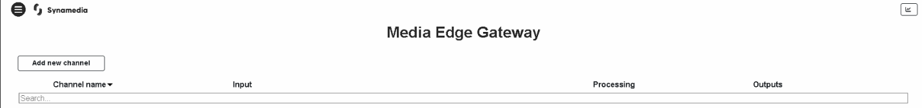

* + Choose which option you would like to do
    - Select **Video Decoding** for SDI setup *(see figure 3)*

figure 3 – Video Decoding

* + Video Decoding – SDI Out
    - Enter a **Channel Name (HSN2 HD MP4 SDI Out)**
    - Select **Use Existing Input**
    - **Input Selection - DVB-S2:DVBS2 1 (4.08GHz)**
  + Select which **Video Decoding** you would like to transcode by choosing the service in the **Dropdown Menu - (23) for HSN2 HD** *(see figure 4)*

figure 4 – Configure Video Decoding

* **Descrambling - Disabled**
* Click on **Video** tab next
  + Configure **Basic Video Settings**
  + Select the **Format** you would like to Decode to
    - Leave as **HD**
  + Select which **Resolution Mode** you would like to use
    - For HD services, select **Follow Input**
    - Leave defaults values for the remainder of settings *(see figure 5)*
* *figure 5 – Choose Format and Codec*

* Click on **Audio** tab next
  + Click on **Add ES: 2301 (MPEG1-L2) (eng)**
    - Enable - Select **Decode to PCM** for MPEG1-L2 audio *(see figure 6)*
    - Leave defaults values for the remainder of settings
  + Click on**Add ES: 2302 (Dolby Digital) (eng)** for Dolby Digital Audio
    - Enable - Select **Passthrough** for Dolby Digital audio *(see figure 6)*
    - Leave defaults values for the remainder of settings

*Figure 6 – Configure Audio Settings*

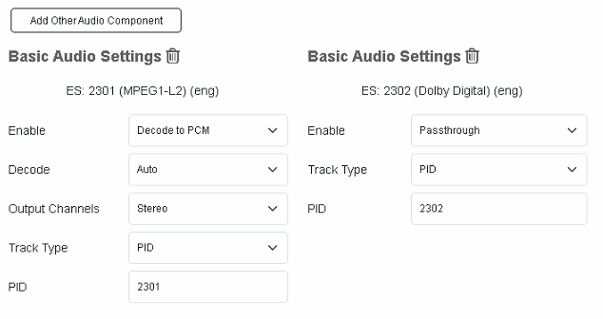

* Click on **Output** next
  + Select **Type** 
    - Select **SDI**
      * Select which **SDI port** you would like to use (SDI-1)
      * Leave remaining fields as default values

*Figure 8 – Configure Output*

* Click on **Create** in upper right corner (*see figure 9)*

*Figure 9 – Create and Finish*

* *You should see a popup box that says “Channel activated successfully”*
* Setup complete –There should now be 1 channel with a green checkmark *(see* **figure 10)**

Figure 10 – Channel Created

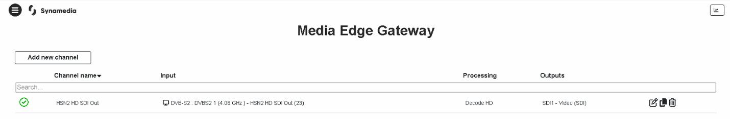

*Advanced View configurations are beyond the scope of this document.